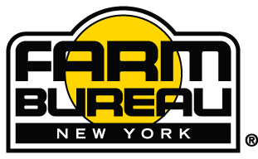

NYFB VIRTUAL STATE ANNUAL MEETING
December 7 – 8, 2020
Zoom/E-Ballot

AGENDA

Monday, December 7:

9:00 a.m. – 12:00 noon Open Resolutions

12:00 – 1:30 p.m. Young Farmer & Rancher Business Session & Elections

2:00 – 3:30 p.m. Promotion & Education Business Session & Elections

7:00 – 7:30 p.m. Zoom/eBallot trial run

7:30 – 8:30 p.m. District Caucuses

Tuesday, December 8:

8:45 a.m. Zoom Meeting Open
Delegate Check-in

9:00 a.m. Call to Order
- Welcome, Patrick McCormick, Chair, SAM Committee
- Pledge of Allegiance
- National Anthem
- Invocation
- Message from AFBF President Zippy Duvall (Pre-recorded)

9:15 – 11:30 a.m. Delegate Session
- Rules of Procedure
- Resolutions

11:30 a.m. – 12:00 noon Business Session
- CEO/Secretary-Treasurer Report
- President’s Address

12:00 – 12:45 p.m. Lunch
- Rolling video with Agribusiness Member logos, YF&R and ProEd messages, video clips of BOD etc.

12:45 p.m. Delegate Session
- Message from Jeff Zellers, Nationwide
- Quorum Confirmation
- Dues and ByLaws
- Elections

- Resolutions (Adjourn upon completion)

