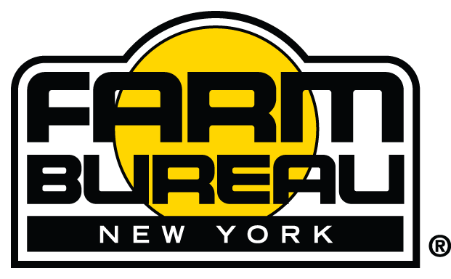
2023 NYFB Agricultural Youth Scholarship Application Outline
Applications may only be submitted online using the Reviewr platform.
The link to the application is: https://my.reviewr.com/site/2023_New_York_Farm_Bureau_Agricultural_Youth_Scholarship

After you create an account in Reviewr, you will log in and begin your application. You can stop, restart, and edit your application any time before the submission is due by logging into your Reviewr account.
Your responses to the questions and essay sections have character count limits. Before you submit your application, you will see a summary page which you can print to review your answers.
To complete the application, the following information will be required, and you will need to answer the following questions:
Applicant Information:
Name
Address
Date of Birth
Phone Number
Email Address
Parent/Guardian Name
County
NYFB Membership #, or Signify that membership application is pending
High School
Chosen Occupation Field
Anticipated College/University/Technical School
Anticipated Major
References:
Two Required – Limit of one teacher and one relevant relative
Letters are not necessary.
PHOTOGRAPH:
Please Upload A RECENT PHOTOGRAPH – a 300 dpi (minimum) of a head/shoulder shot. All photographs submitted by entrants become the property of New York Farm Bureau and may be used for promotional purposes. The submission of a photo and signature on the application form by the applicant is evidence of consent to the above conditions. Applicants under the age of 18 must also include the signature of a parent or legal guardian.
Name and Address of your Local Newspaper:
Application Questions:
- Provide detailed information about your farming and/or agricultural experience (Work on any farm, jobs in agriculturally related fields, 4-H, FFA Classroom, etc). (Include evidence/examples).
- What in particular has inspired or motivated you to pursue a career in agriculture? (Include evidence/examples)
- What are 3 goals you hope to achieve by continuing your education?
- What is 1 major goal you want to achieve as you begin your career?

Activities: Please do not repeat an activity in more than one section.
Please list the agricultural activities you are involved with. Include your leadership roles, service on committees, awards and recognitions received. List years of participation (example: 2019-2020, 2021...).
Examples of agricultural activities: FFA, 4-H, Livestock Breed Club, Equine Riding team …
Organization:
Dates of Participation (Format YYYY, YYYY-YYYY):
Roles, Awards, Recognition:
Please list the school activities (non-agricultural) you are involved with. Include your leadership roles, service on committees, awards and recognitions received. List years of participation (example: 2019-2020, 2021...).
Examples of school activities (non-agricultural): school band, choir, yearbook, Math club, debate team, student government ...
Organization:
Dates of Participation (Format YYYY, YYYY-YYYY):
Roles, Awards, Recognition:
Please list the community activities you are involved with. Include your leadership roles, service on committees, awards and recognitions received. List years of participation (example: 2019-2020, 2021...).
Examples of community activities: Boy Scouts, Girl Scouts, church activities, volunteer at food pantry, volunteer at Senior Center …
Organization:
Dates of Participation (Format YYYY, YYYY-YYYY):
Roles, Awards, Recognition:

Essay:
Think about what you value and stand for in agriculture and life. How have these values impacted your decision on an agricultural career?

